MINISTERS’ DEPUTIES | CM Documents | CM(2025)130 | 8 August 2025
1543rd (Budget) meeting, 18-20 November 2025
11 Programme, Budget and Administration

11.1 Programme and Budget 2024-2027: 2nd biennium 2026-2027 – draft
Secretary General’s proposal (executive summary)

Background

- The Programme and Budget is an integrated document where the Programme covers four years
2024-2027 (the quadrennium) and the Budget consists of two consecutive biennial budgets for 2024-2025 and 2026-2027.

- The Committee of Ministers adopted the Programme and Budget 2024-2027 at its 1481st (Budget) meeting in November 2023. It is recalled that the Programme was approved for the four-year period, the Budget was approved for 2024-2025.

- The 4th Summit (Reykjavik, 16-17 May 2023) continues to provide the fundamental guidance and direction for the Council of Europe’s work over the next biennium.

- This document presents the Secretary General’s proposal for 2026-2027. The draft revised Programme and the draft Budget for 2026-2027 is presented in document CM(2025)130-add. Alternative scenarios are outlined in document CM(2025)130-add2.

- The Secretary General’s proposal has been guided by the discussions between the Secretary General and member States, discussions in the GR-PBA, the outcome of the Ministerial Session and the mid-term review, including the evaluation on the implementation of the Reykjavik Declaration.

- At their meeting on 18 June 2025, the Deputies welcomed the Secretary General’s basic framework set out in document CM(2025)87 and invited him to present the draft revised Programme and Budget for the biennium 2026-2027 on that basis, in the light of the guidelines adopted on the same occasion.

- The timelines for the examination of the draft revised Programme and the draft Budget for the second biennium are presented in Appendix 1. The different steps will be adjusted as necessary to allow sufficient discussions, both in formal and informal settings. The Secretary General’s aim is to conduct the process in a transparent and inclusive manner to ensure member States’ ownership.

Budget Guidelines for 2026

CM/Del/Dec(2025)1532/11.1

The Deputies

1. following initial consultations for the 2026-2027 biennium, endorsed the Secretary General’s proposals on the priorities for the next two years: continuing the support for Ukraine, defining a New Democratic Pact by a broad and inclusive consultation process and strengthening the Council of Europe’s role in the new geopolitical landscape, as a means of promoting its values, priorities and democratic security;

2. took note of the first steps by the Secretary General to overhaul the Organisation’s communication and welcomed his determination to increase the visibility of the Council of Europe, by a more proactive, more impactful, more targeted, more innovative reach out to the general public, and in particular young people;

3. recalled the budgetary efforts collectively undertaken by member States to maintain the level of activities of the Council of Europe following the expulsion of the Russian Federation on 16 March 2022 and their consecutive decisions of 2022-2024, leading to cumulative nominal increases in budgetary contributions, including real increases in resources above inflation for two years in a row, notably for priorities in response to the aggression of the Russian Federation against Ukraine and for a wide range of other topics and non-operational expenses. The Deputies reaffirmed the importance of ongoing reforms to strengthen the Council of Europe’s agility, resilience and efficiency, ensuring budgetary and programmatic reprioritisation and reallocation of existing resources;

4. invited the Secretary General to present a budgetary proposal for the implementation of proposed priorities, including an executive summary, detailed scenarios/options which should leave sufficient margins for decision-making by member States, a breakdown of the annual efficiency gains aiming for at least 2% to be allocated to priorities in paragraph 1, the transversal presentation of programmes, input from intergovernmental committees on the mid-term review of deliverables and their priority order, and other individual proposals to be submitted according to their decisions taken at their 1513th meeting on 27 November 2024 (CM/Del/Dec(2024)1513/11.2-Part1);

5. to this extent, recalled that proposals should focus on the priorities proposed by the Secretary General and topics where the Council of Europe has a competitive advantage and/or unique legal instruments and expertise in support of those priorities, while sunsetting or downsizing, as appropriate, other activities which are of less priority or deemed to have achieved their goal and/or could risk unnecessary duplication with other international organisations;

6. further recalled that priorities should be financed primarily by redeployments and that any increase in real terms would need to be accompanied by strong arguments, including the lack of alternative financing from reallocation of existing resources and efficiency gains;

7. welcomed the Secretary General’s basic framework set out in document CM(2025)87 and invited him to present the draft revised Programme and Budget for the biennium 2026-2027 on that basis, in the light of these guidelines.

Secretary General’s priorities for the 2nd biennium – Strengthening democratic security

- Europe is at a defining point. The principles and values that are guiding member States - human rights, democracy and the rule of law - are being challenged and threatened. Democratic backsliding is a reality, fuelled by disinformation, the rise of authoritarianism, social fragmentation and declining public trust in institutions. Societies are increasingly polarised, weakening social cohesion and making it more difficult to find consensus on democratic principles. At the same time, a new geopolitical landscape is unfolding and impacting Europe’s security.

- Rarely has Europe felt a greater need to find its own solutions to define its security and stand together in the face of shifting alliances and growing uncertainty. Defence, hard security, is only one element of Europe's strategic independence. Democratic security is another, equally important one. Democratic, stable and peaceful societies do not go to war. The Council of Europe - with its geographical strength, its diversity and its 75 years of political, technical and judicial expertise unique in the world – plays a leading role in building democratic security in Europe.

“We see democratic security as key for member States to address current and future challenges together and to secure peace and prosperity in Europe.” (Reykjavik Declaration)

- Democratic security, like hard security, requires a strong political commitment and investment. An important step in this regard was taken in 2023 in Reykjavik by the Heads of State and Government, when they reiterated their commitment to the Council of Europe, its mission and core values. They provided strategic guidance for the years to come, which was translated into a new Programme and Budget 2024-2027 and an increase in the resources allocated by the member States to the Organisation.

Strengthening the Council of Europe’s role in the new geopolitical landscape

- The international order is rapidly changing under the influence of distinct but inextricably linked dynamics. The Council of Europe must play its full role in the new strategic and security architecture that Europe is defining.

- To achieve this, it is crucial to keep the whole European family strong and united. Strengthening its cohesion will guarantee the citizens of our continent a future of peace, stability, prosperity and security. While divergent forces often seem to prevail at present, greater convergence must be found through dialogue and respect, based on our common values. This is not a time for double standards. Our diversity must be a source of enrichment, an added value, not a factor of judgement or division. Now, more than ever, the Council of Europe needs to be the lighthouse in the storm – 46 proud member States, equal in their diversity, uniquely positioned to help shape Europe’s future geopolitical and security architecture.

- This means reinforcing the Council of Europe’s external dimension, strengthening existing partnerships with the European Union and other international organisations, and finding the highest level of synergies with the European Political Community, in the long-term interest of the continent. This also means promoting democratic security beyond our borders. Europe’s security and strategic independence depend on it. Dialogue will be further developed, in particular with the Global South. Co-operation on technical matters, such as artificial intelligence (AI), cybercrime, terrorism or the environment will be broadened.

Supporting Ukraine

- Ukraine and its people are and will remain a top priority. Ensuring accountability is a requirement for lasting peace. Based on the success of the Register of Damage, the Council of Europe has the know-how and capacity to play a leading role in the next steps. Significant progress has been made regarding the establishment of a Claims Commission and a Special Tribunal for the Crime of Aggression against Ukraine, and the Organisation stands ready to put them swiftly in place, should the States so decide.

- Ukraine’s resilience, recovery and reconstruction will continue to be actively supported through the Action Plan, in close co-operation with the national authorities. From judicial reform and anti-corruption measures to safeguarding minority rights and media freedom, the Council of Europe’s work is at the heart of Ukraine’s future as a stable, prosperous and democratic European nation. The situation of the children of Ukraine will continue to be addressed with the active support of the Special Envoy of the Secretary General on the situation of the children of Ukraine. Of the Action Plan's estimated total budget of €65 M, more than €42 M has been secured. An additional €23 M is needed to continue this vital work in 2025 and 2026 – this is key to respond to today’s crisis but also to secure peace and stability for tomorrow.

Addressing democratic backsliding: towards a New Democratic Pact for Europe

- To address the many challenges facing democracy, resolute action is needed. The New Democratic Pact for Europe is about revitalising democracy—making it stronger, more adaptable and more inclusive. All efforts should converge to leverage existing instruments, policies and tools, while proposing new initiatives and approaches, articulated around three pillars:

o Learning and Practising Democracy: building democracy means fostering a critical mind, a culture of debate and an awareness of the common good. This involves strengthening education, civic engagement and ensuring inclusive participation, including for marginalised groups and minorities.

o Protecting Democracy: guaranteeing democratic security means safeguarding democratic institutions, protecting the separation of powers and the independence of the judiciary, ensuring free and fair elections, fighting against corruption, against electoral interference and disinformation, including through the misuse of digital technology and AI.

o Innovating Democracy: guaranteeing democratic security is not enough. It must also be strengthened, renewed and adapted. This means exploring deliberative and participatory democracy, harnessing new technologies to improve accessibility, trust and efficiency in governance. Enhancing the meaningful engagement of youth and civil society will contribute to the development of innovative policies and practices and ensure the long-term resilience of democracy.

- This endeavour will be fuelled by a broad and inclusive consultation process across member States and beyond. Engaging in an open and critical dialogue, the Council of Europe will be the forum for all views, in the respect of the rights and values protected by the European Convention on Human Rights.

- The process will culminate in 2026 with the endorsement of the New Democratic Pact for Europe, a path to a future where democracy is unshakable, where every voice matters, institutions inspire trust, and societies thrive on fairness, inclusion and innovation.

Ensuring an agile and efficient Organisation

- To achieve results, the Council of Europe’s work needs to be more visible, both to decision-makers and to the general public. The Organisation must be more proactive, more impactful, more targeted, more innovative. Communication will be overhauled and events in member States will continue to be organised to reach out more effectively to the general public, and in particular young people.

- Efforts will continue to ensure a more agile, resilient and results-oriented Organisation. Reform initiatives will continue to be implemented to achieve greater transparency, efficiency and effectiveness.

Budgetary framework of the Secretary General’s proposal

- The political support expressed by the Heads of State and Government in the Reykjavik Declaration, was translated into a new Programme and Budget 2024-2027. Through a more integrated structure articulated around 7 operational programmes (cf. CM(2025)130-add), the action of the Organisation focused on strengthening democratic security and countering democratic backsliding by promoting and protecting common values, responding to current challenges and anticipating future challenges, stepping up engagement with civil society and youth, and assisting, within its mandate, Ukraine and other member States and people affected by the Russian Federation’s aggression against Ukraine.

- The 4th Summit’s key outcomes and strategic priorities were translated into an increase in resources in real terms for targeted priority areas, including the European Court of Human Rights, Execution of Judgments, the Office of the Commissioner for Human Rights, the implementation of the Reykjavik Principles for Democracy, the environment, the fight against the smuggling of migrants and the Organisation’s co-operation dimension for the Council of Europe action plans, including for Ukraine. Priority actions were also supported through reallocations within the envelope and the use of time-bound flex funds (cf. §36 below).

- The decisions taken for the first biennium provide a solid base on which to build.

- The Evaluation on the implementation of the Reykjavik Declaration concludes that the response given to the Declaration to date is relevant and effective in general. The Programme and Budget is aligned with the Declaration and important steps have been taken in priority areas, in particular to support Ukraine. Continuation of existing work has been validated by the Declaration and ensures consistency over time. Additional efforts have been made to involve civil society and youth representatives. However, the Evaluation highlights that high expectations remain to be fulfilled with regard to the establishment of a comprehensive compensation mechanism, the protection and promotion of democracy and responses to environmental concerns. It further recommends defining the level of ambition of the Organisation on civil society and youth engagement, decentralisation and the external dimension. It also acknowledges that current funding is unlikely to be sufficient to meet the expectations set by the Declaration.

- The main parameters of the Secretary General’s proposal for 2026-2027 are presented below.

A: Total of member State’s contributions

- The informal discussions between the Secretary General and member States on 14 and 15 April 2025 highlighted broad appreciation of the Secretary General’s overarching goal of democratic security, and the priorities of supporting Ukraine, the New Democratic Pact for Europe and strengthening the Council of Europe’s role in the new geopolitical landscape. In budgetary terms, emphasis was put on a pragmatic, realistic and balanced approach to the budget with a focus on efficiency and optimising available resources and redeployment within the budgetary envelope.

- In this light, the Secretary General proposes to maintain the Organisation’s resources at their current level in real terms with a number of redeployments within the base envelope to support the priorities and organisational reform, bearing in mind that the on-going discussions on the Claims Commission and the Special Tribunal would lead to a real increase in member States’ contributions should they decide to put them in place.

- To maintain the current base budgetary envelope in real terms would mean that in 2026 inflation of 2% would be applied to the total of member States’ contributions to the General Budget and enlarged/partial agreements in France. For enlarged/partial agreements outside France, the applicable inflation rates applicable would be: 2.7% for the North-South Centre (Portugal), 2.8% for Modern Languages (Graz) (Austria), 2.1% for Enlarged Partial Agreement on Cultural Routes (Luxembourg) and 3.3% for the Register of Damage (the Netherlands). For 2027, a forecast inflation rate of 2% has been used.

- Member States’ total contributions are set out in Table a below.

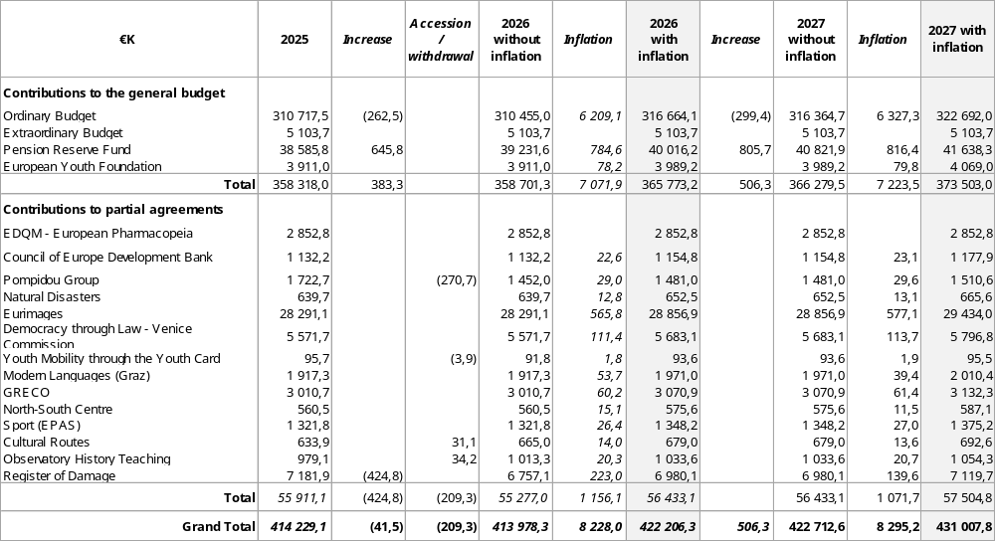

Table a: Member States’ contributions 2026-2027
Notes
(1) Pension Reserve Fund (PRF): member States’ contributions to the PRF are determined on the basis of an actuarial study carried out every four years. An actuarial study was carried out in May 2025 to serve as the basis for calculating contributions from 2026 to 2029. This study is presented in document CM(2025)88. The results of the actuarial study would result in an increase in real terms of €0.4 M in 2026 and €0.5 M in 2027. Further explanations are set out in §40-43 below.

(2) The budgets of Enlarged/Partial Agreements are adjusted to reflect increases or decreases resulting from accessions or withdrawals as follows:

Partial / Enlarged Agreement | Accessions | Withdrawals
Pompidou Group |  | Italy
Youth Mobility through the Youth Card |  | Finland
Cultural Routes | Ireland  Netherlands
Observatory on History Teaching in Europe | Montenegro  Slovak Republic

(3) The budget of the Register of Damage has been reduced to reflect overall lower costs and an increase in voluntary contributions.

(4) Inflation rate: 2% except for enlarged/partial agreements outside France: 2.7% for the North-South Centre (Portugal), 2.8% for Modern Languages (Graz) (Austria), 2.1% for the Enlarged Partial Agreement on Cultural Routes (Luxembourg) and 3.3% for the Register of Damage (Netherlands). For 2027, a forecast inflation rate of 2% has been used.

- Member States’ individual contributions to each budget for 2026 are presented in Appendix 4.

B. Ordinary Budget

- Within the budgetary envelope, €9.4 M, of which €5.6 M is sustainable in nature and €3.8 M flex funds, are available in 2026 for redeployment to support the priorities.

Source of funds available for redeployment to the priorities | €M
Efficiency gains | 4.7
Fixed-sum contributions from enlarged/partial agreements | 0.9
Flex funds | 3.8
Total for 2026 | 9.4

i. Resources identified for redeployment

Efficiency gains

- In line with the Committee of Ministers invitation to seek further budgetary efficiency with quantifiable results whenever possible, efficiency gains are being achieved across the Organisation as part of the ongoing reform initiatives and efforts of the different entities to ensure that the Organisation is delivering the outcomes of the Reykjavik Summit.

- These efforts result in proposed redeployments amounting to €4.7 M within the Ordinary Budget 2026 (and €0.8 M in 2027 (to be updated in the preparation of the 2027 adjusted budget)). They are sustainable and include staff cost containment, rationalisation of structures and optimisation of overheads. The detail of the efficiency gains is presented in Appendix 2.

- In addition, Council of Europe entities continuously adjust and modernise their working methods and tools, enabling them to absorb new needs and activities. Efficiency gains achieved through digital transformation, for example, will enable the Parliamentary Assembly to strengthen its actions to increase outreach and visibility, and the General Administration to implement measures foreseen in the People Strategy and in the action plan for sustainable development and carbon footprint reduction, to support standardised purchase processes in line with audit recommendations and to absorb increased workloads of the Treasury. Efficiency gains thus already reinvested are estimated at €1.3 M.

Fixed-sum contributions from enlarged/partial agreements

- Fixed-sum contributions from enlarged/partial agreements cover the general expenses incurred in the Ordinary Budget on behalf of those agreements. Fixed sum contributions increase by €0.9 M in 2026 (and €0.3 M in 2027). It is proposed to allocate these amounts to support administrative reform efforts, in particular for the implementation of the action plans of the People Strategy (recruitment and mobility, training and development, and well-being).

Flex funds

- Over the biennium 2024-2025, a flex fund was created from high levels of interest income due to higher interest rates. In 2025, the flex funds amounted to €2.9 M and were allocated to priority areas in a time-bound and flexible manner, as the amount of such funds is subject to variations in interest rates. In 2026, it is estimated that the flex funds amount to around €3.8 M (i.e. an additional €0.9 M compared to 2025), reducing to €3.5 M in 2027. A degree of flexibility is kept in the allocation of these funds to reinforce priority actions over the period, including in case of a crisis or unforeseen developments. They are used to finance strictly time-bound activities, allocated for the 2026-2027 biennium only and complemented by extra-budgetary funding where appropriate. In 2026, it is proposed to allocate €3.5 M to the priorities, leaving €0.3 M as a measure of prudence in case interest rates fall or other unforeseen needs arise during the year. In 2027, the margin of prudence is €0.5 M which will be adjusted in the preparation of the adjusted budget for 2027 in the light of the evolution of interest rates.

ii. Proposals to support priority areas

- In 2026, the following adjustments are proposed to support the priorities put forward by the Secretary General:

Priority | €M
Supporting Ukraine | 2.2
Addressing democratic backsliding | 4.0
Strengthening the Council of Europe’s role in the new geopolitical landscape | 0.5
Ensuring an agile and efficient Organisation | 2.4
Total for 2026 | 9.1

Supporting Ukraine (+€2.2 M)

- In line with the Declaration on the Situation of the Children of Ukraine and the commitment of member States to intensify efforts to guarantee the effective protection of their rights in the current context, particular focus continues to be put on the situation of children of Ukraine. The reinforcements (€0.2 M) would strengthen actions in this area, in particular through the work of the Special Envoy on the Situation of the Children of Ukraine, Thórdís Kolbrún Reykfjord Gylfadóttir, to raise awareness of the challenges faced by the children of Ukraine, foster international co-operation with international partners and ensure internal
co-ordination.

- Support to Ukraine’s resilience, recovery and reconstruction would be further supported through the Action Plan, in close co-operation with national authorities. Additional resources (2026: +€2.0 M; 2027: €1.7 M) would be allocated, including for the continuation of the Consultation Group on the Children of Ukraine which provides for a multilateral co-operation platform for member States to address legal and policy challenges related to displaced children of Ukraine.

Addressing democratic backsliding (+€4.0 M)

- To further strengthen the Council of Europe’s capacity to develop common responses to the many challenges to democratic security, it is proposed to reinforce actions in the following areas:

- Countering serious threats to democracy: the proposed reinforcements (+€1.8 M) would be used to strengthen:

      - the fight against corruption, money laundering, organised crime and terrorism – and its financing, by further reinforcing MONEYVAL to allow it to fully comply with the revised Financial Action Task Force (FATF) universal procedures; by supporting the implementation of the Counter-Terrorism Strategy with a focus on addressing the rise of youth involvement in terrorist activities, online radicalisation, and violent extremism, and by the development of new standards in the field of criminal law, including to fight against the smuggling of migrants;
      - action to countering disinformation and foreign interference, including through the preparation of a Council of Europe convention;
      - actions to protect freedom of expression and media freedom, through enhanced co-operation activities, implementation of the ‘Journalists matter’ campaign, reinforcement of the core functioning of the Platform to promote the protection of journalism and safety of journalists ; promotion of the right to access to official documents, as part of the right of information, through the Tromsø Convention;
      - the work on the environment through the implementation of the Strategy on the Environment and the promotion of the new Convention for the protection of the environment through criminal law.

- Fostering action on new and emerging digital technologies, including AI: to continue ensuring a leading role for the Council of Europe in a rapidly evolving context, the additional resources (+€0.5 M) would support the promotion of the ratification of the Framework Convention on Artificial Intelligence and Human Rights, Democracy and the Rule of Law, further work on non-legally binding guidance on risk and impact assessment for AI systems tailored to the protection and promotion of human rights, democracy and the rule of law (HUDERIA), and the preparation of tools and regulatory frameworks for the integration of AI in education.

- Addressing growing challenges to equality: to counter the spread of hate speech and anti-rights narratives which undermines the cohesion of societies and the full, equal and meaningful participation of all in political and public life, the additional resources (+€0.5 M) would support human rights-based narratives and cooperation activities to combat hate speech, hate crime and discrimination, and the negative effect of the use of digital technologies in this regard as well as policy work on gender mainstreaming.

- Further integrating a youth perspective and step up engagement with civil society: to elevate youth voices and better involve civil society in the Council of Europe’s work, the reinforcements (+€0.7 M) would support the implementation of the Reference Framework for a youth perspective to be adopted in October 2025 at the 10th Council of Europe Conference of Ministers Responsible for Youth and foster civic engagement through support for thematic platforms for dialogue with NHRIs and national preventive mechanisms (NPM), the functioning of the HELP Programme and broader interaction with civil society.

- Strengthening the capacity of the Court: the additional resources (+€0.5 M) would further strengthen its capacity to deal with the backlog of well-founded cases, by securing over the biennium, in the Ordinary Budget, additional jobs currently funded by extrabudgetary resources and support digital modernisation, thus completing the efforts made in the first biennium, as per the compromise reached when adopting the Programme and Budget 2024-2027.

- Supporting the Parliamentary Assembly: the additional resources (+€0.1 M) would support its integrity framework and its efforts to integrate a youth perspective in its work.

- Supporting the Congress, the additional resources (+€0.1 M), would reinforce its monitoring activities and support its efforts to integrate a youth perspective in its work.

Strengthening the Council of Europe’s role in the new geopolitical landscape (+€0.5 M)

- To reinforce the external dimension of the Organisation, strengthen partnerships with the European Union and other international organisations, ensure greater synergies with the European Political Community and increase the strategic dimension of the Organisation’s communication, the reinforcements would increase in particular the capacity of the Private Office of the Secretary General and the Deputy Secretary General.

Ensuring an agile and efficient Organisation (+€2.4 M)

- The Secretary General is committed to continuing reform initiatives to ensure a more agile, resilient and results-oriented Organisation and to achieve greater transparency, efficiency and effectiveness. The main drivers underlying the reform process (new and ongoing initiatives 2026-2027) were set out in the basic framework (cf. CM(2025)87) and have been included in the revised Programme and Budget – Section d. (cf. CM(2025)130-add).

- As part of these efforts to ensure a more agile, resilient and result-oriented Organisation, the reinforcements will support in particular:

      - the implementation of the action plans of the People Strategy, and in particular to plan and recruit better and faster and to enhance internal mobility; to strengthen the results-oriented and learning culture; and to support well-being related activities (+€1.0 M);

      - the implementation of the new Council of Europe Strategy on Decentralisation and Staff Mobility
2025-2028 and the stabilisation of core support roles for the design, management and delivery of projects funded by extra-budgetary resources (+€0.7 M);

      - the digital transformation of the Organisation, by deploying AI tools and modernising the online working tool for the Committee of Ministers (+€0.7 M).

- Further details of the above proposals are presented in Appendix 3. The Secretary General’s proposals presented per programme over the biennium are set in Appendix 4.

Staff departure scheme

- Departure schemes are financed inter alia by internal loan mechanisms which consist in authorising expenditure in advance and reimbursing it over a certain period in equal instalments through budgetary allocations from future budgets. One such mechanism was approved in 2021 for a total of €2.4 M reimbursed over five years in equal instalments of €0.48 M with the last instalment in 2025. It is proposed to renew this mechanism to launch a departure scheme for the 2026-2027 biennium i.e. €2.4 M reimbursed over five years in equal instalments of €0.48 M with the last instalment in 2030.

C: Pension Reserve Fund (PRF)

- The total annual member State contributions to the Pension Reserve Fund (PRF) are determined on the basis of actuarial studies carried out in general every four years. Member States’ direct contributions to the PRF represent the difference between the total annual contributions and the employer contributions included in the various budgets (Ordinary Budget, subsidiary and service budgets, partial agreements) or charged to extrabudgetary resources.

- An actuarial study was carried out in May 2025 to serve as a basis for calculating contributions from 2026 to 2029. This study is presented in document CM(2025)88-add and its budgetary implications in document CM(2025)88. The application of the results of the actuarial study would imply an increase in the total financing needs in real terms in 2026 of €2.9 M.

- To avoid a sharp increase in 2026, it is proposed to smooth the increase in financing needs over a four-year period as follows, which the Budget Committee also recommends:

In € M  (in real terms) | 2025 | 2026 | 2027 | 2028 | 2029
Total Financing needs | 78.1 | 78.8 | 79.5 | 80.1 | 80.6
Variation (N-N-1) |  | +0.7 | +0.7 | +0.6 | +0.5

- The split of the total financing needs between the various budgets has been determined during the preparation of the detailed Budget for 2026-2027. This shows that part of the real increase in 2026-2027 would be covered by increased contributions from the EDQM and extrabudgetary resources, giving a real increase in member States’ contributions to the PRF of €0.4 M in 2026 and €0.5 M in 2027.

Appendix 1: Timelines

- The main steps in the phase leading up to the approval of the revised Programme and Budget for the 2nd biennium are presented below:

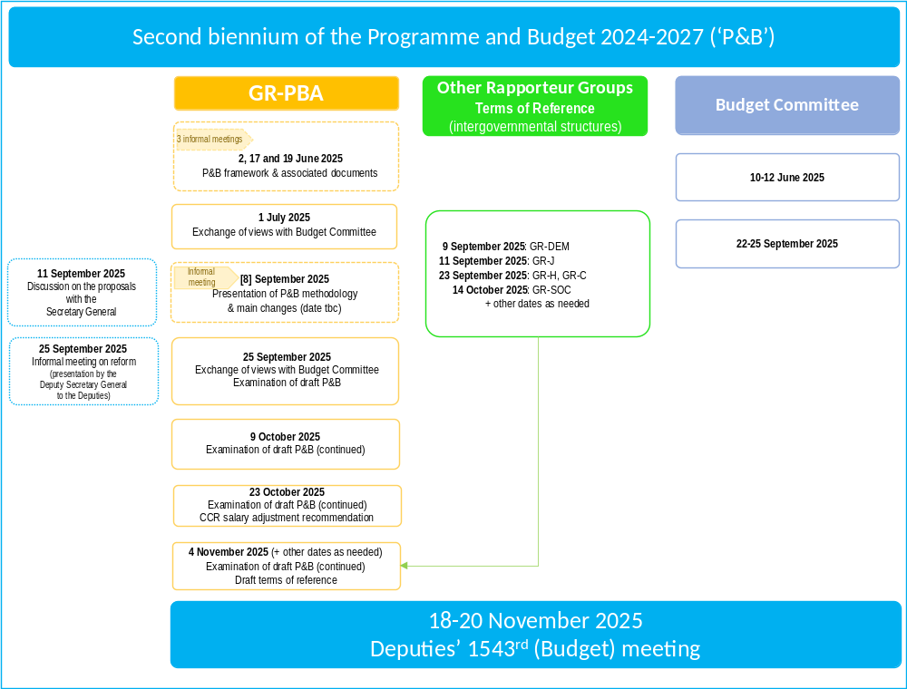

- The draft revised Programme and draft Budget for 2026-2027 was distributed in August 2025, including an executive summary, scenarios/options, and highlighting any changes to the sub-programmes.

- To make the best use of the available time to carry out a thorough examination, it is proposed to start the process in the GR-PBA in early September 2025 with a presentation of the rationale, main parameters and main changes to the Programme, and of the key reform measures foreseen for 2026-2027.

- The thematic Rapporteur Groups will examine any changes to the provisionally agreed terms of reference in September/October and the outcome of those discussions will feed into the deliberations in the GR-PBA.

- Discussions in the GR-PBA will continue over October and November to prepare the decisions to be adopted at the Committee of Ministers’ Budget meeting on 18-20 November 2025.

- After the adoption, it is proposed to reflect on lessons learnt during the process to be taken into account in future cycles.

Appendix 2: Detail of the efficiency gains for redeployment

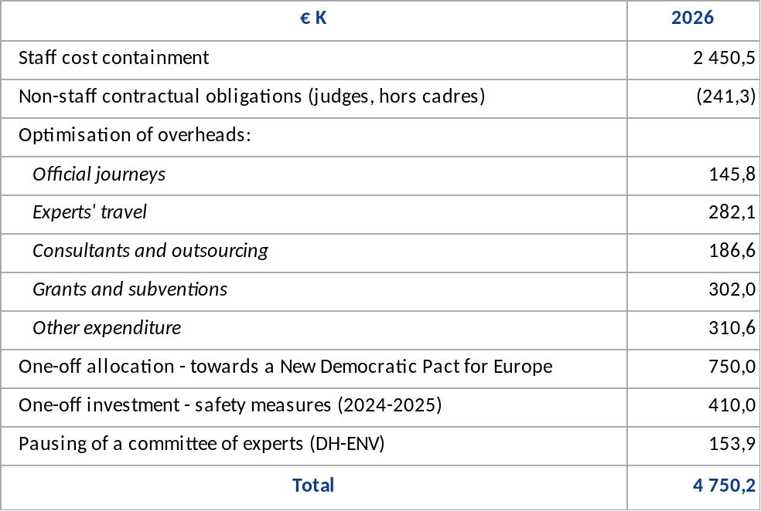
Appendix 3: Detail of proposals to support priority areas

Supporting Ukraine (+ €2.2 M)

- SUPPORTING UKRAINE | Total  €K | Source of financing (€K)
- SUPPORTING UKRAINE | Total  €K | Efficiency gains | Flex
1.1 Addressing the situation of children of Ukraine  The Secretary General proposes to strengthen actions in this area, in particular through the work of his Special Envoy on the Situation of the Children of Ukraine, Thórdís Kolbrún Reykfjord Gylfadóttir, appointed in February 2025. The resources would support her in fulfilling her mandate, to raise awareness of the challenges faced by the children of Ukraine and promoting Council of Europe standards, initiatives and activities in support of children of Ukraine; to ensure internal co-ordination and cooperation with all Council of Europe relevant entities, and to foster international co-operation and identify opportunities for synergies with international partners.  staff: 1A, 1B; non-staff: €100.0 K | 249.5 |  | 249.5
1.2 Supporting the implementation of the Action Plan for Ukraine and the Consultation Group on the Children of Ukraine  The Secretary General also proposes to secure resources for the implementation of the Action Plan for Ukraine 2023-2026. Of the Action Plan's estimated total budget of €65 M, more than €43 M has been secured. Additional resources are needed to continue this vital work – this is key to respond to today’s crisis but also to secure peace and stability for tomorrow.  This would include support for the continuation of the Consultation Group on the Children of Ukraine, which provides since November 2023 for a multilateral co-operation platform for member States to address legal and policy challenges related to displaced children of Ukraine. Key areas of focus would include, inter alia, psychological support and trauma-informed care, understanding the risks of trafficking of children of Ukraine, access to education, preconditions for the safe return of children from Council of Europe member States and reforms to Ukraine’s child-protection system. The needs for 2026 are estimated at €0.7 M.  non-staff: €2000.0 K | 2 000.0 |  | 2 000.0
TOTAL | 2 249.5 |  | 2 249.5

Addressing the democratic backsliding (+€4.0 M)

2. ADDRESSING THE DEMOCRATIC BACKSLIDING | Total  €K | Source of financing (€K)
2. ADDRESSING THE DEMOCRATIC BACKSLIDING | Total  €K | Efficiency gains | Flex
2.1 Countering serious threats to democracy  Guaranteeing democratic security requires addressing serious threats to democracy. Actions would be strengthened, in particular the fight against corruption, money laundering, organised crime and terrorism – and its financing, notably by further:  - reinforcing MONEYVAL to allow it to fully comply with the revised Financial Action Task Force (FATF) universal procedures, as highlighted in the Progress Review Report 2024 and the mid-term review;  staff: 5A  - supporting the implementation of the Counter-Terrorism Strategy 2023-2027 with a focus on addressing the rise of youth involvement in terrorist activities, online radicalisation, and violent extremism, and by the development of new standards in the field of criminal law, including to fight against the smuggling of migrants.  staff: 1A, 1B; non-staff: €106.0 K  Threats to democracy also include attacks on freedom of expression and media freedom. It is proposed to further strengthen cooperation activities in this area to support member States in implementing the Council of Europe standards in this field, in particular to build resilience to disinformation and support media in the context of digital convergence. The commitment to press freedom would be strengthened by further advancing the ‘Journalists matter’ campaign and reinforcing the core functioning of the Platform to promote the protection of journalism and safety of journalists. Resources would also reinforce the capacity and visibility of the work on the right to access to official documents, as part of the right of information and in view of the increase of the number of Parties to the Tromsø Convention.  staff: 3A, 2B; non-staff: €151.0 K  Particular focus would be put on countering disinformation and foreign interference, which have become major challenges, including to fair and electoral processes. Proposed resources would be used to prepare a Council of Europe Convention in this area. Draft terms of reference for an ad hoc committee have been distributed in document CM(2025)131-add to this end.  staff: 1A, 1B; non-staff: €264.0 K  Work on the environment would also be supported to ensure the implementation of the Strategy on the Environment and the promotion of the new Convention for the protection of the environment through criminal law.  staff: 1A | 1 764.5 | 1116.1 | 648.4
2.2 Fostering action on new and emerging digital technologies, including AI  The Framework Convention on Artificial Intelligence and Human Rights, Democracy and the Rule of Law was adopted in 2024. Proposed resources would be used to promote its ratification, to work on non-legally binding guidance on risk and impact assessment for AI systems tailored to the protection and promotion of human rights, democracy and the rule of law (HUDERIA) and to continue ensuring a leading role for the Council of Europe in the field of new and emerging digital technologies. Draft terms of reference for a steering committee have been distributed in document CM(2025)131-add to this end.  staff: 1A, 1B  Resources would also support the preparation of tools and regulatory frameworks for the integration of AI in education, in the framework of the Education Strategy 2024-2030 “Learners first: Education for today’s and tomorrow’s democratic societies”.  non-staff: €110.0 K | 316.3 | 206.3 | 110.0
2.3 Addressing growing challenges to equality  Persistent and emerging challenges to equality, including gender equality, require enhanced action, in particular to address the spread of hate speech and anti-rights narratives which undermines the cohesion of societies and the full, equal and meaningful participation of all in political and public life. Proposed resources would support human rights-based narratives and cooperation activities to combat hate speech, hate crime and discrimination, and the negative effect of the use of digital technologies in this regard. It is also proposed to strengthen the management of co-operation activities in the field of anti-discrimination and to support policy work on gender mainstreaming.  staff: 2A, 1B; non-staff: €200.0 K | 505.2 | 149.2 | 356.0
2.4 Further integrating a youth perspective and stepping up engagement with civil society  In line with the Reykjavik Declaration and taking into account the Evaluation of the integration of a youth perspective, it is proposed to increase resources to elevate youth voices in the work of the Organisation and to support the implementation of the Reference Framework to be adopted in 2025, developing guidance and practical tools and piloting actions in selected sectors.  staff: 1A, 2B; non-staff: €200.0 K | 664.6 | 664.6

It is also proposed to foster civic engagement through support to civil society, including National Human Rights Institutions (NHRIs) and Ombudsperson institutions, promoting their role and ensuring their meaningful participation of in the work of the Organisation. Resources proposed would support the work of thematic platforms for dialogue with NHRIs and national preventive mechanisms (NPM), the functioning of the HELP Programme and the capacity of the Organisation to interact broadly with civil society.
staff: 1A, 1B; non-staff: €115.0 K
2.5 Strengthening the capacity of the Court  It is proposed to further strengthen the Court's capacity to deal with the backlog of well-founded cases, by securing in the Ordinary Budget additional jobs currently funded by extrabudgetary resources and support its digital modernisation efforts, thus completing the efforts made in the first biennium, as per the compromise reached when adopting the Programme and Budget 2024-2027.  staff: 3A; non-staff: €175.0 K | 471.7 | 471.7
2.6 Supporting the Parliamentary Assembly  It is proposed to support the strengthening of Parliamentary Assembly's integrity framework and its efforts to integrate a youth perspective in its work. Other requests included in Resolution 2604 (2025) on Expenditure of the Parliamentary Assembly for the biennium 2026-2027 are presented under Scenario A (cf. CM(2025)130-add2).  staff: 2B | 114.2 | 114.2
2.7 Supporting the Congress  It is proposed to reinforce the monitoring activities of the Congress and to support its efforts to integrate a youth perspective in its work. Other requests included in Recommendation 520 (2025) on the Congress Budget for 2026–2027 are presented under Scenario A (cf. CM(2025)130-add2).  staff: 2B | 134.2 | 134.2
TOTAL | 3 970.7 | 2 856.3 | 1 114.4

Strengthening the Council of Europe’s role in the new geopolitical landscape (+€0.5 M)

3. STRENGTHENING THE COUNCIL OF EUROPE’S ROLE IN  THE NEW GEOPOLITICAL LANDSCAPE | Total  €K | Source of financing (€K)
 | Total  €K | Efficiency gains | Flex
3.1 Secretary General and Deputy Secretary General: To reinforce the external dimension, strengthen partnerships with the European Union and other international organisations, ensure greater synergies with the European Political Community and increase the strategic dimension of the Organisation’s communication, it is proposed to reinforce the capacity of the Private Office of the Secretary General and the Deputy Secretary General.  Staff: 2A, 2B; non-staff: €110.0 K | 472.5 | 472.5
3.2 External relations: it is proposed to further support liaison offices, in particular to increase resources for hospitality and official travels. | 30.0 | 30.0
3.3 DLAPIL: it is proposed to increase resources to support the work on public international law and the promotion of treaties. | 35.0 |  | 35.0
TOTAL | 537.5 | 502.5 | 35.0

Ensuring an agile and efficient Organisation (+€2.4 M)

4. ENSURING AN AGILE AND EFFICIENT ORGANISATION | Total  €K | Source of financing (€K)
4. ENSURING AN AGILE AND EFFICIENT ORGANISATION | Total  €K | Efficiency gains | Flex | Fixed Sum
4.1 People Strategy / RBM and governance:  Proposed reinforcements would support the implementation of the action plans of the People Strategy, and in particular:  - to support the recruitment and mobility team to plan and recruit better and faster and to enhance internal mobility;  - to strengthen the learning culture and development, including by increasing the access to relevant training learning opportunities for staff; and  - to support well-being related activities and to provide mental health support.  staff: 2A, 5B; non-staff: €286.1 K  It is also proposed to further support the implementation of the Results-oriented Management Strategy 2023-2027 and the continuous improvement and use of the RBM methodology within the Organisation.  staff: 1A  Administrative support would also be provided to the internal controller and to the Administrative Tribunal.  staff: 1B, temp €58.0 K; non-staff: €10.0 K | 963.4 | 68.0 |  | 895.4
4.2 Strategy for Decentralisation and Mobility and supporting the co-operation dimension  Proposed reinforcement would support the implementation of the new Council of Europe Strategy on Decentralisation and Staff Mobility 2025-2028, in particular;  - to secure new regional roles on security and procurement in the field;  - to cover increased running costs of the offices.  staff: 4B; non-staff: €260.0 K  It is also proposed to stabilise co-operation support roles for the design, management and delivery of projects funded by extra-budgetary resources.  staff: 4B | 663.3 | 663.3
4.3 Deployment of AI  Digital transformation would be further supported by providing staff access to AI tools in line with a recommendation of the Directorate of Internal Oversight.  non-staff: €660.0 K | 660.0 | 660.0
4.4 Modernise CM online working tools: it is proposed to modernise working methods through investment in an online working tool for the Committee of Ministers.  non-staff: €80.0 K | 80.0 |  | 80.0
TOTAL | 2 366.7 | 1 391.3 | 80.0 | 895.4

Appendix 4: Secretary General’s proposal per programme

Reallocations within the envelope

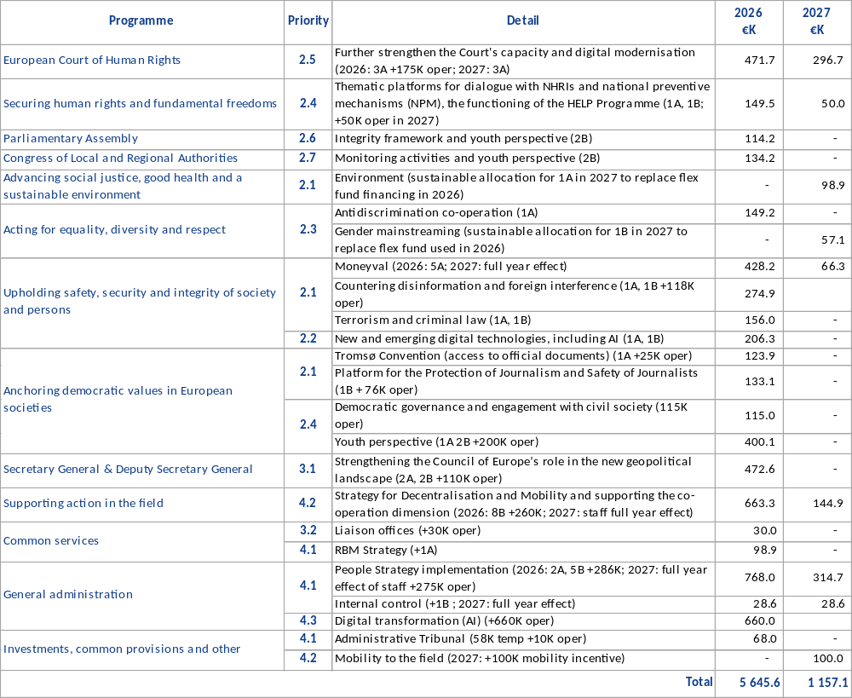

Use of the Flex Fund

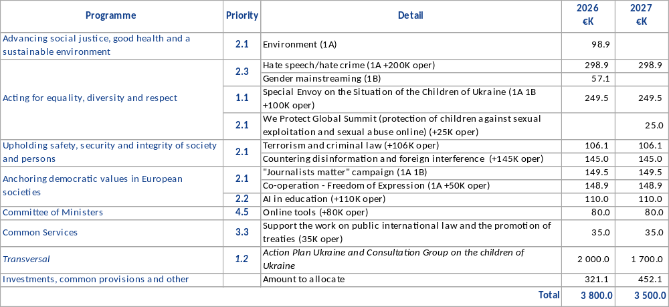

Appendix 5: Individual member States’ contributions for 2026

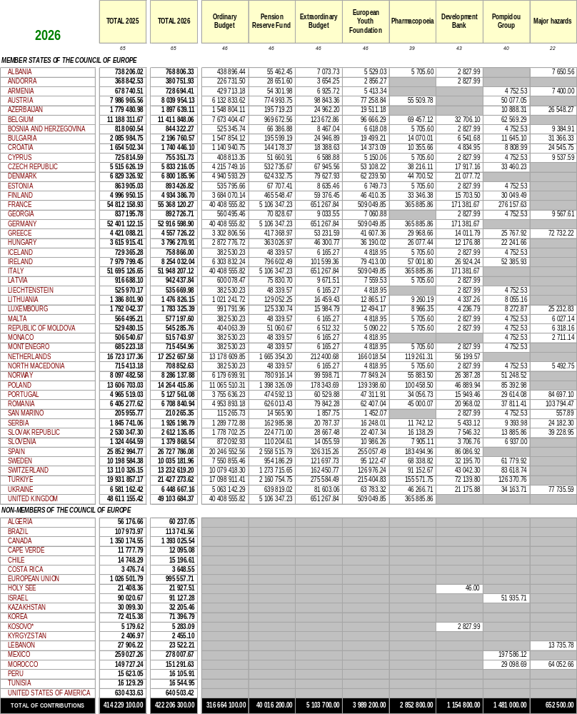
*All reference to Kosovo, whether to the territory, institutions or population, in this text shall be understood in full compliance with United Nations Security Council Resolution 1244 and without prejudice to the status of Kosovo.

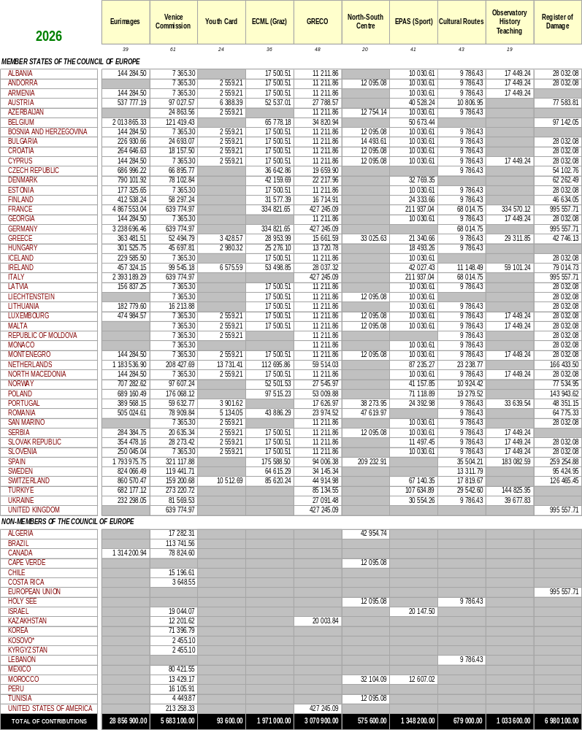

This document has been classified restricted until examination by the Committee of Ministers.
The Budget for 2025 was approved on a provisional basis in November 2023 and an adjusted Budget for 2025 was subsequently approved at the Deputies’ 1513th meeting in November 2024.
Cf. CM(2025)86.
Cf. SG/Inf(2025)14.
Cf. Section a – Main parameters and Appendix X of the Programme and Budget 2024-2027 (CM(2025)1).
Cf. Evaluation Report, Management Response and Action Plan.
Cf. GR-PBA(2025)6.
Eurostat rates (12-month average rates), end February 2025. The forecast inflation rate of 2% for 2027 would be updated next year for the Eurostat inflation figure for the period ending in February 2026.
Eurostat rates (12-month average rates), end February 2025. The forecast inflation rate of 2% for 2027 would be updated next year for the Eurostat inflation figure for the period ending in February 2026.

